**Activity 21**

**NAME : Abinaya COURSE: MOBILE COMPUTING**

**REG NO : 192421208 COURSE CODE: ITA0302**

21. In Figma, design a mobile app interface that prioritizes user connectivity and convenience. Highlight key elements.

**Aim:**

To design a mobile app interface that prioritizes user connectivity and convenience.Highlight key elements.

**Procedure:**

1. Create a file

2. Add The First Frame

3. Add Shapes

4. Add Text

5. Create The Second Frame

6. Add Prototyping

**Step By Step Procedure :**

**Interface Of Experiment**



**Menu Page**:

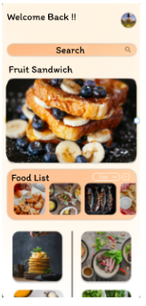

Final Step:

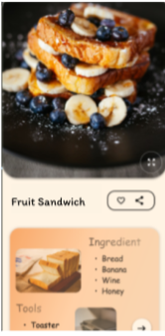

Prototype:

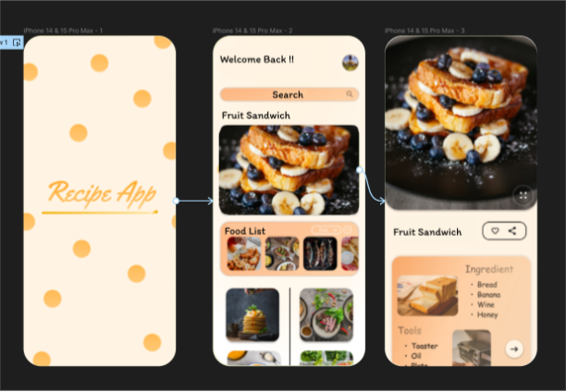

**Result:**

Hence the mobile app interface that prioritizes user connectivity created and executed successfully.